**Project supermarket – part 2**

**Do not forget to**

* Make a **copy / backup** of your project on a regular basis if you have finished a part of this assignment, so that you can fall back on it if something has gone wrong...
* **Add your name and student number in each file in comments.**
* **Please note****:** we know that a lot of information/code is exchanged between students to help each other. This is absolutely no problem when doing the exercises. However, the project has PE points, so must be made **INDIVIDUALLY/PERSONALLY**.
* So if you use/copy someone else's code or you help someone with the code, we can no longer assess someone’s knowledge/capabilities individually. This is a form of fraud: both for the person copying and for the person who has copied. See OER (Education and Examination Regulations). Make sure that you make your project individually and do not "share" your code with other students. So do not put your code on "social media/shared cloud" to help each other and do not use it there. The Java teachers are there to help everyone....

**The class diagram:**

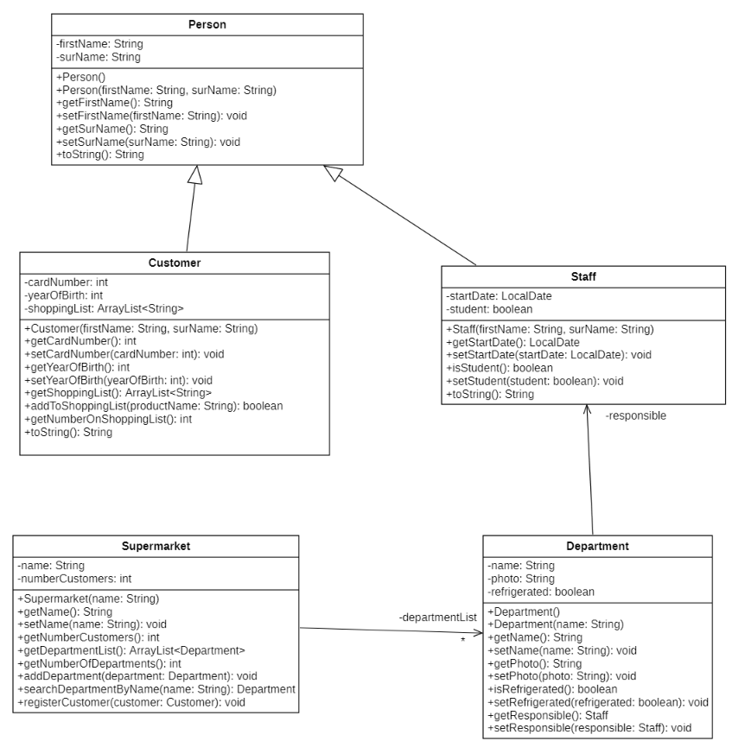

**Basis MVC**

**General:**

* Afbeelding met tekst

  Automatisch gegenereerde beschrijvingIn the *static.img* folder you will find the file *style.css*. Use this to add a self-selected css to your project.   
  Use this link-tag:  
  <link rel="stylesheet" type="text/css" href="img/style.css" />  
  It's best to use a simple css that is easy to use. (Do not make a header that is very / too large…)
* Provide a nice, consistent layout.
* Make your code readable, maintainable and efficient.
* You choose the names of the html pages yourself, but stick to the prefix we will give you.
* Put your name and student number in comment lines in each file.

**Pages index.html and 1_xxx.html** (replace xxx with a logical name you have to choose yourself)

Make sure that the home page *index.html shows* the name of your application and your own name.

Add **a link 'New customer’** on the index-page. This link will takethe user to a html-page on which a user can fill in the values of a new customer. Give this html-page a logical name but be careful to start this name with the prefix *“****1_***”. On this html page you provide:

* + a hyperlinkto go back to the home page. You can put this at the bottom of your page.
  + a form so that the customer can enter his first name, surname and year of birth. The MainController creates a new Customer object with the given first name, surname and year of birth and redirects you to another html page whose name starts with **2_.**

**Page 2_xxx.html** (replace xxx with a logical name you have to choose yourself)

On this page you welcome the customer by showing his details (use *toString*), but you also add a link to go back to the home page (index.html).

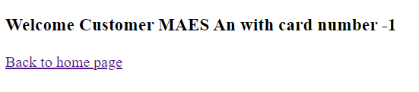

**Pages 3_xxx.html and 4_xxx.html** (replace xxx with a logical name you have to choose yourself)

On the index page, put a **second link 'New staff member'** which will takeyou to the next html page whose name starts with “**3_”.** On this html page you will see the following information:

* + A hyperlink to go back to the home page. You can put this at the bottom of your page.
  + A form that allows you to register a staff member on the basis of his first name, surname and startDate. You can fill in this date according to the pattern dd/MM/yyyy. With the checkbox you can indicate whether or not the employee is a working student.

The MainController creates a new Staff object with the given information and sends you to another html page whose name starts with **4_.** On this page you show the details of the new staff member using the *toString* method and a link to get back to the index page.

